Initial Notes
I reverted back to old mixing as before
Fixed the silence at end bug
I have added more feedback when creating folders or zip file
Added "completed x of x files sucessfully".

FEEDBACK 3, 2016/08/02

c) unchecking boxes 'flac' folder makes the program still creates it. It shouldn't be created.
Not on my system – please check again

I have checked it number of time. It's still being created. No matter if boxes are set or unset. Only org dir is not created mp3 and flac are created always on my system.
That is indeed very strange as you can see from my screenshot
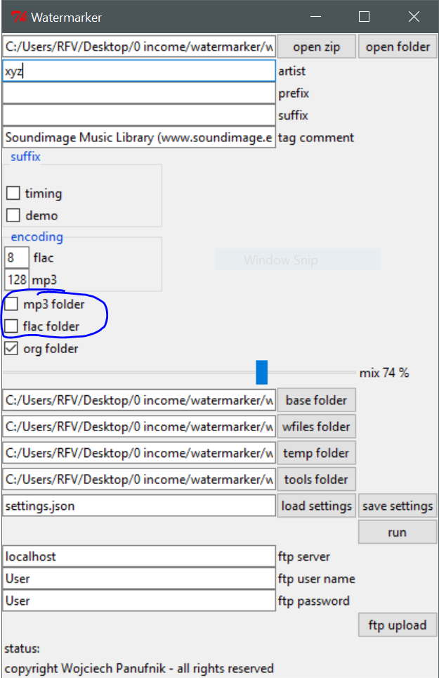

It is not producing the mp3 and flac, I will chack again later.

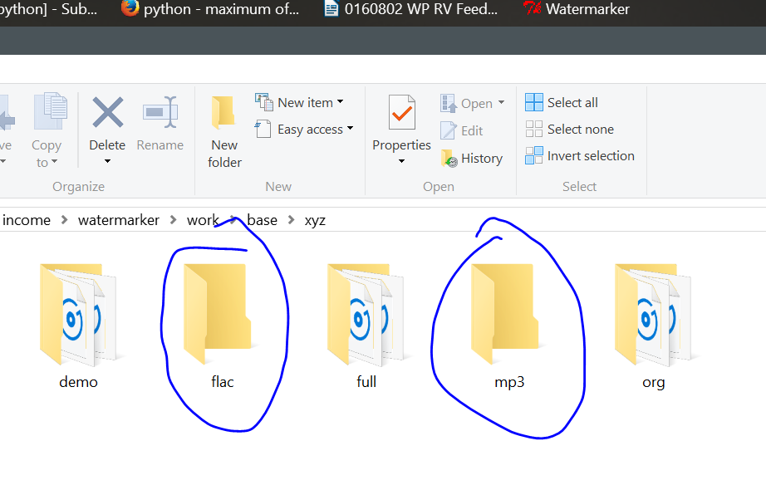

e) As you can see they are in fact 48Kz samples, not 44,100 like the other samples.
What would you like to do here?

So in my opinion to make it possible to mix those files they should be converted to 44.1kHz. Program should check it and convert to 44.1kHz always when org file has different frequency. It's very important as I got very often has two different frequency wav files in the same processing session.
I will do this for the next iteration ok.

>>In your case, because the underlying sample is picked up as louder, therefor the mixing program uses a louder version of the wfile, which when put together will create an even louder output. This is the same principle that you use when you do your mixing, at the end of your chain you use dynamic compression for this season. I asked you before if we need to implement dynamic compression and you said no.

After 20+ years spent with audio production I know very well that mixing underlaying track with a different sample causes that output file will have hight peaks in the area where the audio files are overlayed one on the other. It's not about the problem but when you comapre on ear both examples mentioned one in 0:08 and the other in 0:19 you can easily hear that underlaying track is not raising it's volume, just very very slightly and the mixed in w-file (0:19) is uncomparabelly louder than the previous w-file (0:08) mixed in at very comparable level of sound of underlaying track (i-file).

I am not talking about noticalbe peaks, I am ok with them. It's just the proof that the w-file in 0:19 is mixed far too loud while w file in 0:08 is mixed ok. I just don't know why it happens. Becasue the reason is not rising of volume of i-file.

I asked you before if we need to implement dynamic compression and you said no.

Yes and I would say the same now as we don't need any compression here. Compression would affect entire music and it wouldn't be acceptable. Once again it's not about lack of compression but there is a somekind (minor) problem with alogirthm or rather providing the data to it maybe. Is it sure that you it is taking the volume exactly from the i-file area where w-chunk is going to be mixing it? I mean maybe it looks a bit before or ahead? Just to be 100% if you could check it as I found that if track is silent but it lasts silet for longer it works ok, but if it's silent and w-chunk is mixed close to loud part (but doesn't overlay on it) sometimes it works not too accurate in that moment. This is why I thought is this exactly the same area of i-file where w-chunk will be mixed in where the algorhythm checks the loudness?

0 ^ 1.5 = 0
0.5 ^ 1.5 = 0.35355339059327376220042218105242
0.6 ^ 1.5 = 0.46475800154489002622151184797389
0.7 ^ 1.5 = 0.58566201857385288358472041804963
0.9 ^ 1.5 = 0.85381496824546241963970125699683
1 ^ 1.5 = 1

This is my last freeby suggestion, because these things take extra time and effort, not that I wish to charge you, but I think I have done my part so far.
I have already implemented this, please try the examples now

Ok Thank you for the effort, I appreciate you are trying a different method to make the mixing effect more accurate, as it's the core function of this tool. I spent hours yesterdays of mixing and listinening. I just compared both methods previous and the new you featured. I mixed and listened to more than 200 tracks. So my first points were that tracks which have equal loundess througout enitre duration are mixed fine with both methods. They only need different mixing ratio (mix%). The old one about 45 and new one about 73 to be comparable.
Then I chosen tracks where I found most problems with new method. And there tracks were those which has variable loundness (consisiting of very silent / very loud parts ). Those tracks are mixed better with previous method, thoght still not perfect. So the conclusion is: please revert to the prvious method.

Though the best option would be to have a select field mix-method1 (old), mix-method2 (new). Is it possible? If having both option is additional cost let me know, please.
For now I have reverted back to the old method. What I will do in the next iteration is to another slider that will change the curve value from 0.0 to inf. (1 being the old original value - straight line, less then one - make softer areas even more soft, more then1 - inverse curve) so two parameters to adjest the loudness settings.
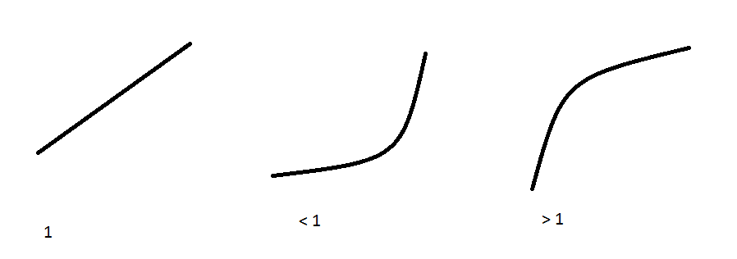

I understand now, (excluding the org folder) time/length and demo only in demo folder. Bitrate in all
I have removed the bitrate checkbox

Naming is correct now.

Ryan, this not new feature. I included it in the specs. And it's not like complaing about it now as it is very important feature for me. I was asking in the specs to make it configurable the offset/time delay of entire w-files chain which is mixed in. For e.g. if in the a process first w-file is mixed in 0:08 if we set the offset to 0:00 sec, the first w-file should be mixed from 0:00 sec for all files in this process. It's liek a hard offset for first w-file and all next w-file chunks being mixed after should be moved proportionaly left in the time line. If we set offset to 0:05 sec. All first w-file should be mixed in 0:05 sec and all other should be mover proportionaly (according to the normal algorigithm from mixing table for such i-file) to the right in the time line (they should be deleyed 5 seconds, all). Do you understand what I mean? It's very important feature. Optional. By default shouldn't be used.
No actually you specified the exact wfile time offsets in the specs originaly, which we then changed later (which also took a lot of extra time btw) – what you are asking for now is a feature for you to be able to change those values yourself.
You can currently find all the wfile configuration stuff in the processing.py file lines 4 – 16
Moved do next milestone
No actually you specified the exact wfile time offsets in the specs originaly, which we then changed later (which also took a lot of extra time btw) – what you are asking for now is a feature for you to be able to change those values yourself.

I am not asking you to create configurable mixing matrix, no. I aksed only for a small feature of making it possible to set a delay / offset which could make the move entire w-files sequence in time. To show it in the specifications it's on page 4 Item 2 (MIXING), subitem d:
"d. w-file time offset (configurable). By default first word of the w-file should be heard after 8 seconds of the mix. But it should be possible to set this value in the configuration. "

also in the end of specifications it is also listed in section "Other configurable options not mentioned above" (thought this was mentioned):
  - w-file time offset

Ofcourse I am not asking you for to make mixing matrix configurable in this phase, no... If I could describe it in the simplest form it would be a possibility to manualy set the delay of enitre w-file sequence which will affect in the same way, globally every w-chunk. So in fact what we need is manual possibilyty to set the begining value used for mixing in w-chunks. And there is no need to alter differently for different i-file lengths what we have by default. By default it stays like it is programmed in the mixing matrix now. But once this value is set manualy (by a slider) begining value should be changed globally for mixing any i-file of any length. It's important for me to have it. If it's very complicated or for some reason you didn't understood it from the specs let's charge for that.

I think I understand now, ok, so for each encoding session, appart from the usual harcoded into silence part that wfile cant be mixed into ifile, you wish to specify additional intro silence (via slider), will this include or exclude the usual intro silence setting?

FTP UPLOAD:

I have implemented an ftp upload feature on the gui and it works from my side. I have run filezilla ftp server and tested the upload on that ftp server. Everthign that have just been processesd will be uploaded to the ftp server of your choice. The setting are also saved in the setting file_

Thank you very much for implementing this. For some reason I can not use this FTP UPLOAD. My FTP access data in client like total commander is:
host name: soundimage.home.pl
remote directory: /public_html/soundimage/tracks2add
user: .....
password: ....
What should I type in FTP SERVER field in Watermarker to access the mentioned bellow remote directory? Now, according to the remote dir I have to upload to I typed there as follows:

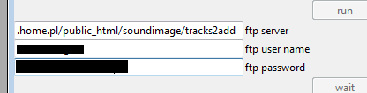

And I get this error in Command Line:

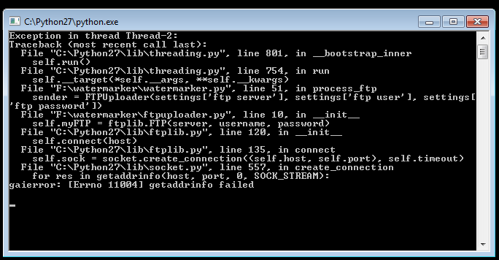
Could you please help with that?
You need to put only the server [soundimage.home.pl] into the ftp server setting. I will have to add another input input level to specify which folder you wish to use for the upload.

One new problem I found

I can not use mixing for those files (see attached sfx.zip). They are probably too short and here W-Files sequence feature would help me with proper mixing (by setting begining margin to 0).
I assume that you will ask me: how can I mix w-file to the file which is shorter than w-file. So if I could reply to such question: obviously mixing is impossible but I don't want the program to crash in such case. If I am watermarking sound effets I have very long sound effect and sometimes very short ones. So if program find too short i-file and it is the case we have now with the error can it just avoid mixing w-file on this i-file and process everything like now (mp3 conversion, tagging, flac conversion, etc).

Final Words
I think for the most part things are working good, I did fix that ending silence thing, that was my fault.
Things which need work:
- Check why the program is encoding mp3 and flac on your computer when it really should not.
- Convert all audio files which are not 44.1 Kz to 44.1 Kz for mixing
- Add one more slider for fine grain mix settings
- Add extra beginning silence slider to customize each encoding session
- Trim [beginning, end]
- Add extra input to specify ftp folder to use on your server.
- All other feature specified in other specs document + more that you require.

Considering that this job is a little bit complicated, woul dit be possible to do these in the next milestone for say 100 USD. At the moment I have 2 jobs pending, one I will finish tonight. If you want I could dedicate my day tomorrow and finish the rest hopefully by tomorrow and at the latest over the weekend?

